Term Project

AML140830

Alex Lundin

# 1. Written answers to the questions in the Project Questions area.

**5 more rules**

1. Employee
   1. Primary key
      1. Employee_ID
2. Potential Employee
   1. Primary key
      1. Potential_Employee_ID
3. Customer
   1. Primary key
      1. Customer_ID
4. Catalog
   1. Combination of Part_ID and vendor_ID
5. Product
   1. Product_ID
6. Shift
   1. Shift_ID

**Is the ability to model super class and sub class likely to be important in this type of environment? Why or why not**

Yes, because there are several types of person object in the database, employee, potential employee and customer. Each person type shares the 12 base attributes of the person object and then each type adds on their own unique attributes from there.

**Justify using a relational DBMS Software for this project**

A database management system software is required for this enterprise business logic. Computer systems are extremely ideal for this type of logging system with multiple entity types that relate to eachother.

# 2. EER diagram

Portrait 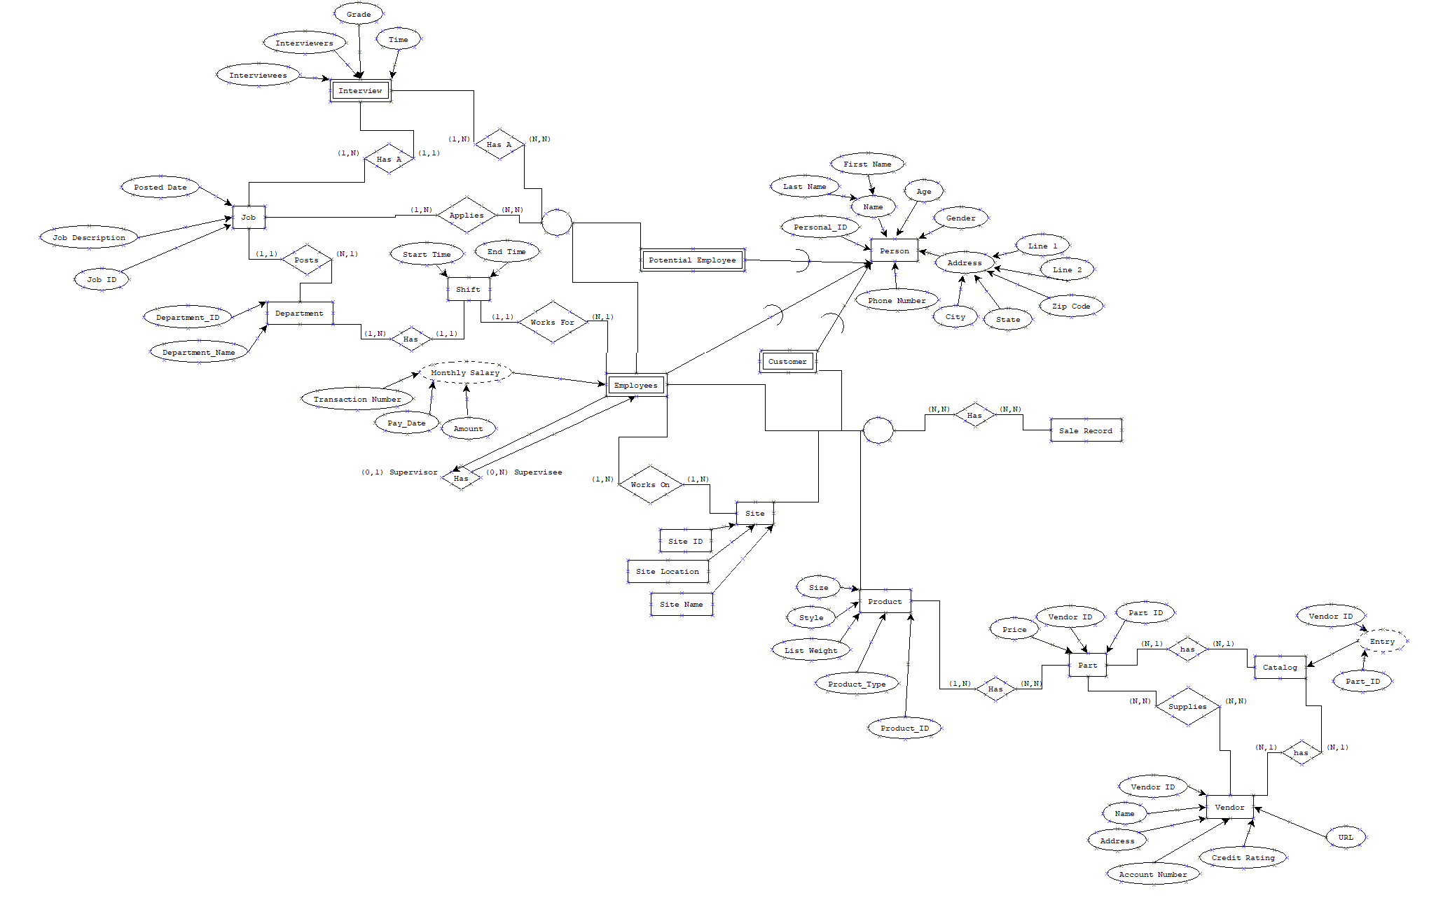

Landscape



# 3. Relational schema

# The main relations stemmed from the personal_ID and employee_ID

# 

# 

# 

# 4. Database structure

# 

# 5. Database SQL setup script

CREATE TABLE person (

first_name VARCHAR2(30) NOT NULL,

last_name VARCHAR2(30),

personal_id INTEGER NOT NULL,

age INTEGER,

gender VARCHAR2(1),

address_line_1 VARCHAR2(30),

city VARCHAR2(30),

address_line_2 VARCHAR2(30),

state VARCHAR2(30),

zip_code INTEGER,

phone_number INTEGER,

primary key (personal_id)

);

CREATE TABLE customer (

prefered_salesman VARCHAR2(30),

customer_id INTEGER NOT NULL,

personal_id INTEGER NOT NULL,

primary key (customer_id),

foreign key (personal_id) references person

);

CREATE TABLE monthly_salary (

transaction_numer INTEGER NOT NULL,

pay_date DATE,

amount FLOAT,

monthly_salary_id NUMBER NOT NULL,

primary key (monthly_salary_id)

);

CREATE TABLE employee (

title VARCHAR2(30),

supervisor_id INTEGER,

employee_id INTEGER NOT NULL,

monthly_salary_id NUMBER,

transaction_numer INTEGER,

personal_id INTEGER NOT NULL,

primary key (employee_id),

foreign key (personal_id) references person,

foreign key (monthly_salary_id) references monthly_salary

);

CREATE TABLE potential_employee (

potential_employee_id INTEGER NOT NULL,

personal_id INTEGER NOT NULL,

primary key (potential_employee_id),

foreign key (personal_id) references person

);

CREATE TABLE interviewee (

interviewee_id INTEGER NOT NULL,

potential_employee_id INTEGER NOT NULL,

primary key (interviewee_id),

foreign key (potential_employee_id) references potential_employee

);

CREATE TABLE interviewer (

job_id INTEGER,

interviewer_id INTEGER NOT NULL,

employee_id INTEGER NOT NULL,

primary key (interviewer_id),

foreign key (employee_id) references employee

);

CREATE TABLE interview (

job_position INTEGER,

interview_time TIMESTAMP,

interviewee_id INTEGER NOT NULL,

job_id INTEGER NOT NULL,

interviewer_id INTEGER NOT NULL,

interview_id INTEGER NOT NULL,

grade NUMBER,

primary key (interview_id),

foreign key (interviewer_id) references interviewer,

foreign key (interviewee_id) references interviewee

);

CREATE TABLE department (

department_id INTEGER NOT NULL,

department_name VARCHAR2(30 CHAR),

primary key (department_id)

);

CREATE TABLE job_position (

job_id INTEGER NOT NULL,

job_description VARCHAR2(30),

posted_date TIMESTAMP,

department_id INTEGER NOT NULL,

primary key (job_id),

foreign key (department_id) references department

);

CREATE TABLE product (

p_size VARCHAR2(25),

p_style VARCHAR2(25),

list_weight VARCHAR2(25),

product_id INTEGER NOT NULL,

product_type VARCHAR2(25),

product_name VARCHAR2(25),

part_id INTEGER NOT NULL,

primary key (product_id),

foreign key (part_id) references part

);

CREATE TABLE part (

price NUMBER,

part_id NUMBER NOT NULL,

primary key (part_id)

);

CREATE TABLE vendor (

vendor_id INTEGER NOT NULL,

name VARCHAR2(25),

address VARCHAR2(25),

account_number INTEGER,

credit_rating INTEGER,

url VARCHAR2(25),

primary key (vendor_id)

);

CREATE TABLE catalog (

catalog_id NUMBER NOT NULL,

part_id NUMBER NOT NULL,

vendor_id INTEGER NOT NULL,

primary key (catalog_id),

foreign key (part_id) references part,

foreign key (vendor_id) references vendor

);

CREATE TABLE sales_record (

sale_time DATE,

sales_record_id NUMBER NOT NULL,

sales_id INTEGER NOT NULL,

employee_id INTEGER NOT NULL,

customer_id INTEGER NOT NULL,

product_id INTEGER NOT NULL,

primary key (sales_id),

foreign key (employee_id) references employee,

foreign key (customer_id) references customer,

foreign key (product_id) references product

);

CREATE TABLE shift (

end_time TIMESTAMP,

start_time TIMESTAMP,

employee_id INTEGER NOT NULL,

shift_id INTEGER NOT NULL,

department_id INTEGER NOT NULL,

primary key (shift_id ),

foreign key (department_id) references department,

foreign key (employee_id) references employee

);

CREATE TABLE site (

site_id INTEGER NOT NULL,

site_location VARCHAR2(20),

site_name VARCHAR2(20),

primary key (site_id)

);

CREATE SEQUENCE monthly_salary_id START WITH 1 NOCACHE ORDER;

CREATE OR REPLACE TRIGGER monthly_salary_id BEFORE

INSERT ON monthly_salary

FOR EACH ROW

WHEN ( new.monthly_salary_id IS NULL )

BEGIN

:new.monthly_salary_id := monthly_salary_id.nextval;

END;

/

CREATE SEQUENCE part_id_seq START WITH 1 NOCACHE ORDER;

CREATE OR REPLACE TRIGGER part_id_trg BEFORE

INSERT ON part

FOR EACH ROW

WHEN ( new.part_id IS NULL )

BEGIN

:new.part_id := part_id_seq.nextval;

END;

/

CREATE SEQUENCE sales_record_id START WITH 1 NOCACHE ORDER;

CREATE OR REPLACE TRIGGER sales_record_id BEFORE

INSERT ON sales_record

FOR EACH ROW

WHEN ( new.sales_record_id IS NULL )

BEGIN

:new.sales_record_id := sales_record_id.nextval;

END;

/

# 6. Sample populated tables

--- employees

INSERT INTO person (first_name, last_name, personal_id, age, gender, address_line_1, city, address_line_2, state, zip_code, phone_number) VALUES ('Alex','Lundin',1, 26, 'M', '123 Street', 'McKinney', '456 Street', 'TX', 75070, 4663945275);

INSERT INTO person (first_name, last_name, personal_id, age, gender, address_line_1, city, address_line_2, state, zip_code, phone_number) VALUES ('John','Smith',2, 26, 'M', '123 Street', 'McKinney', '456 Street', 'TX', 75070, 4663945275);

INSERT INTO person (first_name, last_name, personal_id, age, gender, address_line_1, city, address_line_2, state, zip_code, phone_number) VALUES ('Suezy','Q',3, 26, 'F', '123 Street', 'McKinney', '456 Street', 'TX', 75070, 4663945275);

--- sales

INSERT INTO person (first_name, last_name, personal_id, age, gender, address_line_1, city, address_line_2, state, zip_code, phone_number) VALUES ('ZZ','Top',5, 26, 'M', '123 Street', 'McKinney', '456 Street', 'TX', 75070, 4663945275);

INSERT INTO person (first_name, last_name, personal_id, age, gender, address_line_1, city, address_line_2, state, zip_code, phone_number) VALUES ('James','Bond',6, 26, 'M', '123 Street', 'McKinney', '456 Street', 'TX', 75070, 4663945275);

INSERT INTO person (first_name, last_name, personal_id, age, gender, address_line_1, city, address_line_2, state, zip_code, phone_number) VALUES ('Batman','Wayne',7, 26, 'M', '123 Street', 'McKinney', '456 Street', 'TX', 75070, 4663945275);

--- pot emp

INSERT INTO person (first_name, last_name, personal_id, age, gender, address_line_1, city, address_line_2, state, zip_code, phone_number) VALUES ('Sarah','Smith',4, 26, 'F', '123 Street', 'McKinney', '456 Street', 'TX', 75070, 4663945275);

INSERT INTO person (first_name, last_name, personal_id, age, gender, address_line_1, city, address_line_2, state, zip_code, phone_number) VALUES ('Hellen','Cole',8, 26, 'F', '123 Street', 'McKinney', '456 Street', 'TX', 75070, 4663945275);

--- customers

INSERT INTO CUSTOMER (PREFERED_SALESMAN, CUSTOMER_ID, PERSONAL_ID) VALUES ('Batman', 1, 1);

INSERT INTO CUSTOMER (PREFERED_SALESMAN, CUSTOMER_ID, PERSONAL_ID) VALUES ('James Bond', 2, 2);

INSERT INTO CUSTOMER (PREFERED_SALESMAN, CUSTOMER_ID, PERSONAL_ID) VALUES ('ZZ Top', 3, 3);

--- salary

INSERT INTO MONTHLY_SALARY (TRANSACTION_NUMER, AMOUNT, monthly_salary_id) VALUES (1, 50000, 1);

INSERT INTO MONTHLY_SALARY (TRANSACTION_NUMER, AMOUNT, monthly_salary_id) VALUES (2, 60000, 2);

--- employees

INSERT INTO EMPLOYEE (EMPLOYEE_ID, PERSONAL_ID, MONTHLY_SALARY_ID) VALUES (1, 5, 1);

INSERT INTO EMPLOYEE (EMPLOYEE_ID, PERSONAL_ID, MONTHLY_SALARY_ID) VALUES (2, 6, 2);

--- pot employees

INSERT INTO POTENTIAL_EMPLOYEE (potential_employee_id, PERSONAL_ID) VALUES (1, 4);

INSERT INTO POTENTIAL_EMPLOYEE (potential_employee_id, PERSONAL_ID) VALUES (2, 8);

--- interviewee

INSERT INTO interviewee (interviewee_id, potential_employee_id) VALUES (1, 1);

INSERT INTO interviewee (interviewee_id, potential_employee_id) VALUES (2, 2);

--- interviewer

INSERT INTO interviewer (job_id, interviewer_id, employee_id) VALUES (12345, 1, 1);

INSERT INTO interviewer (job_id, interviewer_id, employee_id) VALUES (11111, 2, 2);

--- interview

INSERT INTO interview (job_position, interview_time, interviewee_id, job_id, interviewer_id, interview_id, grade) VALUES (job_position, interview_time, interviewee_id,job_id,interviewer_id,interview_id,grade);

# 7. Views from part 2d

# 8. Queries from part 2e.

1) Return the ID and Name of interviewers who participate in interviews where the interviewee’s name is “Hellen Cole” arranged for job “11111”.

select PERSON.FIRST_NAME, PERSON.LAST_NAME, PERSON.PERSONAL_ID

from person

where PERSON.FIRST_NAME = 'Hellen'

AND PERSON.PERSONAL_ID =

(select POTENTIAL_EMPLOYEE.PERSONAL_ID

FROM POTENTIAL_EMPLOYEE

where PERSON.PERSONAL_ID = POTENTIAL_EMPLOYEE.PERSONAL_ID

AND POTENTIAL_EMPLOYEE.POTENTIAL_EMPLOYEE_ID =

(select INTERVIEWEE.POTENTIAL_EMPLOYEE_ID

FROM INTERVIEWEE

where INTERVIEWEE.POTENTIAL_EMPLOYEE_ID = POTENTIAL_EMPLOYEE.POTENTIAL_EMPLOYEE_ID

)

);

2) Return the ID of all jobs which are posted by department “Marketing” in January, 2011.

3) Return the ID and Name of the employees having no any superviesees.

select EMPLOYEE.PERSONAL_ID, PERSON.FIRST_NAME

from EMPLOYEE

INNER JOIN PERSON

ON EMPLOYEE.PERSONAL_ID = PERSON.PERSONAL_ID;

WHERE EMPLOYEE.SUPERVISOR_ID = null

AND EMPLOYEE.PERSONAL_ID =

(select PERSON.PERSONAL_ID

from person

where PERSON.PERSONAL_ID = EMPLOYEE.PERSONAL_ID

);

4) Return the Id and Location of the marketing sites which have no any sale records during March, 2011.

5) Return the job’s id and description which does not hire a suitable person one month after it is posted.

6) Return the ID and Name of the salesmen who have sold all product type whose price is above $200.

7) Return the department’s id and name which has no job post during 1/1/2011 and 2/1/2011.

8) Return the ID, Name, and Department ID of the existing employees who apply job “12345”.

9) Return the best seller’s type in the company (sold the most items).

10) Return the product type whose net profit is highest in the company (money earned minus the part cost).

11) Return the name and id of the employees who has worked in all departments after hired by the company.

12) Return the name and email address of the interviewee who is selected.

13) Retrieve the name, phone number, email address of the interviewees selected for all the jobs they apply.

14) Return the employee’s name and id whose average monthly salary is highest in the company.

# 15) Return the ID and Name of the vendor who supply part whose name is “Cup” and weight is smaller than 4 pound and the price is lowest among all vendors.

# 9. Dependency diagrams

